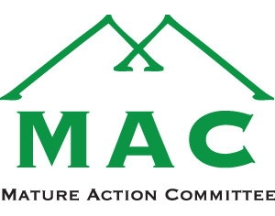

MEMBERSHIP DUES -2013

To be a member in “Good Standing” and eligible to vote on motions at our Annual General Meeting, April 8th, 2013, full payment of dues is required. Annual dues of $15 per member are now due for the year commencing February 1st, 2013.

For your convenience, dues are payable online at www.whistlermac.org (PayPal). You may also mail your dues to the address below, or pay when attending the Annual General Meeting.

The payment of dues adds strength to MAC’s voice in advocacy efforts, and provides an indication to MAC that you wish to remain an active member supporting the goals of housing, programming and support services for Whistler residents 55+.

If you have remitted your dues for 2013 prior to this notice, please accept our thanks.

If you have any questions regarding this matter please contact the Membership Chair,
Marg Pallot 604.932.0866 or mpallot@telus.net

